There is a room with n bulbs, numbered from 1 to n, arranged in a row from left to right. Initially, all the bulbs are turned off.

At moment *k* (for *k* from 0 to n - 1), we turn on the light[k] bulb. A bulb **change color to blue** only if it is on and all the previous bulbs (to the left) are turned on too.

Return the number of moments in which **all turned on** bulbs **are blue.**

**Example 1:**

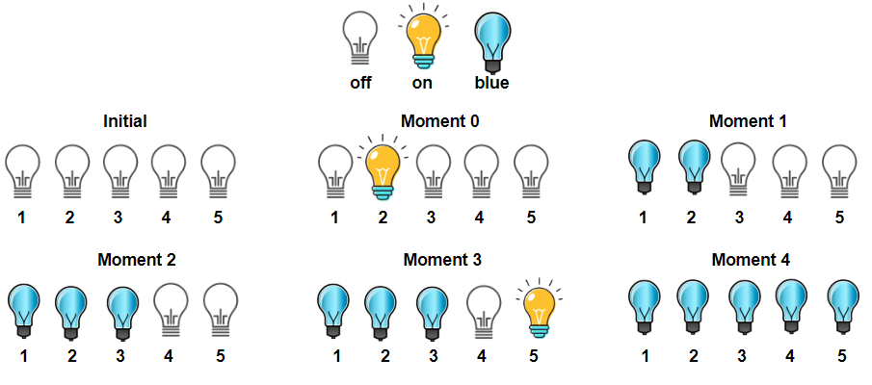

**Input:** light = [2,1,3,5,4]

**Output:** 3

**Explanation:** All bulbs turned on, are blue at the moment 1, 2 and 4.

**Example 2:**

**Input:** light = [3,2,4,1,5]

**Output:** 2

**Explanation:** All bulbs turned on, are blue at the moment 3, and 4 (index-0).

**Example 3:**

**Input:** light = [4,1,2,3]

**Output:** 1

**Explanation:** All bulbs turned on, are blue at the moment 3 (index-0).

Bulb 4th changes to blue at the moment 3.

**Example 4:**

**Input:** light = [2,1,4,3,6,5]

**Output:** 3

**Example 5:**

**Input:** light = [1,2,3,4,5,6]

**Output:** 6

**Constraints:**

* n == light.length
* 1 <= n <= 5 * 10^4
* light is a permutation of  [1, 2, ..., n]